**Sprint 2 - Accuracy Design Document**

**April 9, 2021**

Armand Valentino, Kristina Good

**Table of Contents**

**1.** **EXECUTIVE SUMMARY**

1.1 Project Overview

1.2 Purpose and Scope of this Specification

**2.** **PRODUCT/SERVICE DESCRIPTION**

2.1 Product Context

2.2 User Characteristics

2.3 Assumptions

2.4 Constraints

2.5 Dependencies

**3.** **REQUIREMENTS**

3.1 Functional Requirements

3.2 Security

*3.2.1* *Protection*

*3.2.2* *Authorization and Authentication*

3.3 Portability

**4.** **REQUIREMENTS CONFIRMATION/STAKEHOLDER SIGN-OFF**

**5.** **SYSTEM DESIGN**

5.1 Algorithm

5.2 System Flow

5.3 Software

5.4 Hardware

5.5 Test Plan

5.6 Task List/Gantt Chart

5.7 Staffing Plan

# 

# 1. Executive Summary

## ***1.1*** ***Project Overview***

The goal of this project was to create a program that would make a Sphero SPRK robot complete 5 laps around a figure 8 course.

## ***1.2*** ***Purpose and Scope of this Specification***

This project is to show that our team can create a program that shows how steady this robot can follow a course. This is only part 2 of the final project. It also shows how we can work as a team.

# 2. Product/Service Description

Many general factors and considerations must be taken into account when talking about this program. Steps will be taken to ensure a smooth operation.

## ***2.1*** ***Product Context***

This product runs independently with a user, and works in unison with the EDU programs on the computer.

## ***2.2*** ***User Characteristics***

Anyone can use this software and product, including younger people. For the most part they are also used for/by:

· Student/faculty/staff/other

· experience

· technical expertise

## ***2.3*** ***Assumptions***

Here describes any constraints or dependencies this design may need or encounter.

## ***2.4*** ***Constraints***

Some factors may limit the program from running properly with the product

· Battery life/limits

· Space, especially for courses

· Access, management and security

· Up-to-date software

· Any unexpected glitch

## 

## ***2.5*** ***Dependencies***

Dependencies examples that will most definitely affect the program:

· This program must need a secure Bluetooth connection between computer and product (Sphero)

· Program needs a computer to execute the commands

# 3. Requirements

Many of the requirements listed within this section have been set in place from the computer science department here at Monmouth. These will be crucial in deciding whether our team successfully completed portions of this project.

## ***3.1*** ***Functional Requirements***

The following table represents the requirements laid out for Sprint 2 Accuracy:

|  |  |  |  |  |  |
| --- | --- | --- | --- | --- | --- |
| **Req#** | **Requirement** | **Comments** | **Priority** | **Date Rvwd** | **SME Reviewed / Approved** |
| Accuracy_01 | Start and finish in the same square tile | The robot had difficulty trying to finish the 5 lap course exactly where it started; video shows it did stop very near the start point | Important | April 16th | Completed |
| Accuracy_02 | Complete 5 laps around the figure 8 course |  | Necessary | April 16th | Completed |
| Accuracy_03 | Robot speaks “I am the winner” |  | Important | April 16th | Completed |
| Accuracy_04 | Robot flashes different lights for five seconds |  | important | April 16th | Completed |

## ***3.2*** ***Security***

### **3.2.1** **Protection**

Certain factors must be ensured before the robot performs its activities. For example:

- Flat surface

- No obstruction or obstacles (Sprint 2)

### **3.2.2** **Authorization and Authentication**

Our team and progress will be overlooked by Professor Gil Eckert

## ***3.3*** ***Portability***

The Sphero company offers many products, including the SPRK. Our program can run on any SPRK device. Furthermore,

- Sphero SPRK can be operated anywhere, so long as the Sphero EDU program is running on a computer or laptop capable

# 4. Requirements Confirmation/Stakeholder sign-off

|  |  |  |
| --- | --- | --- |
| **Meeting Date** | **Attendees** | **Comments** |
| 4-15 | Armand Valentno, Krstina Good | n/a |

# 5. System Design

## ***5.1*** ***Algorithm***

The algorithm for Sprint 2 must be followed similar to the following:

* Looping the following code (5 times)
  + Set a specific speed
  + Spin for 360 degrees for x seconds
  + Spin -360 degrees for x seconds
* Stop the robot
* Speak "I am the winner"
* LEDs ON: fade (color) to (color) for a second
* Fade from (color) to (color) for a second
* Fade from (color) to (color) for a second
* Fade from (color) to (color) for a second
* Fade from (color) to (color) for a second
* END

## ***5.2*** ***System Flow***

## Below is the system flow chart mapping out what our block code for Sprint 2 should look like:

## 

● The actual block coding program that was created and used on the robot is below, along with the sensor data showing the completion of 5 laps around the Accuracy sprint figure 8 court:

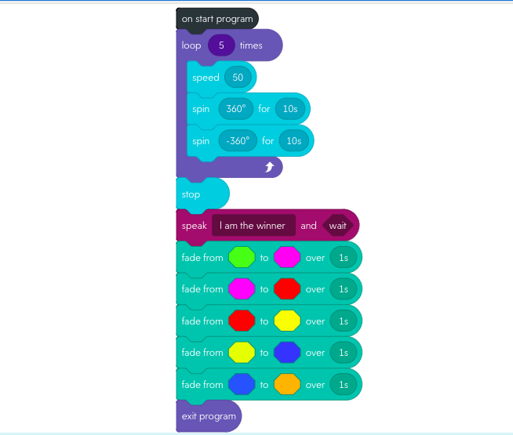

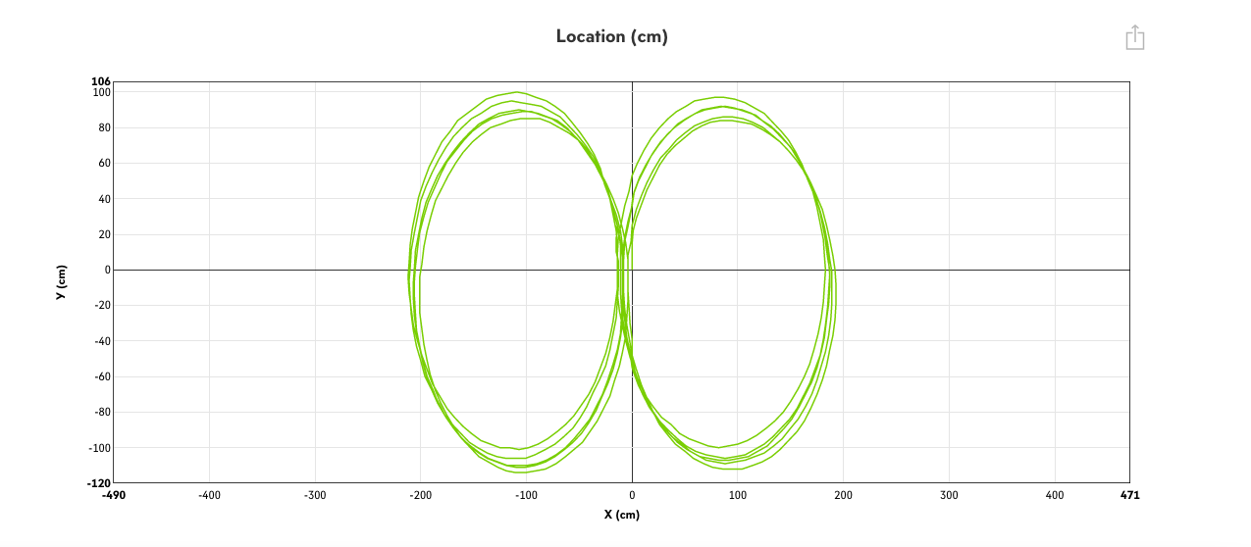

***5.3*** ***Software***

The software used to create and run this program is called Sphero EDU. Within the application, block coding is an option to create programs for the Sphero SPRK robot, which is what our team used.

## ***5.4*** ***Hardware***

Our team used a MacBook to test our product and its coding design.

## ***5.5*** ***Test Plan***

|  |  |  |  |  |  |
| --- | --- | --- | --- | --- | --- |
| **Reason for Test Case** | **Test Date** | **Expected Output** | **Observed Output** | **Staff Name** | **Pass/Fail** |
| Attempt a circle using raw motor block | 4-15 | Make a decent sized circle | not as efficient, too difficult to determine exact circumference of circle | Kristina, Armand | Fail |
| Attempt circle using spin+speed block | 4-15 | Make a circle that sized up with floor layout | Circle was drawn better, but not big enough | Kristina, Armand | Fail |
| Increasing duration of Spin block (10 seconds) | 4-15 | Increase in time = larger circumference | Near perfect circle that followed the layout on the floor | Kristina, Armand | Pass |
| -360 degrees in spin block after first 10 second spin | 4-15 | Complete one lap of figure eight | Completed one lap | Kristina, Armand | Pass |
| Light configuration and spoken word | 4-15 | Change colors and speak after completing 5 laps | After some slight changes to code, test was achieved completed | Kristina, Armand | Pass |

## 

## ***5.6*** ***Task List/Gantt Chart***

The Gantt Chart below represents how and what we have planned/completed in Sprint 2

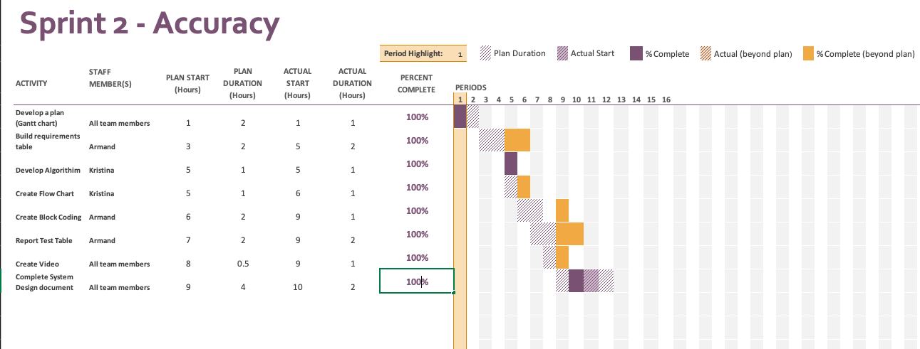

## ***5.7*** ***Staffing Plan***

Below lists a table of contributors to the project, and what roles and responsibility

|  |  |  |  |
| --- | --- | --- | --- |
| Name | Role | Responsibility | Reports To |
| Kristina Good | Coder/contributor | Gantt Chart, Develop algorithm,create flowchart, videographer, completing system design | Professor Gil Eckert |
| Armand Valentino | Coder/coder contributor | Gantt Chart, Create code, completing system design | Professor Gil Eckert |